Golf Bag 2 - Further Information

Foreword by Magnus Magnusson and Sir Michael Bonallack

Endorsement from Colin Montgomerie

List of Contents of the Golf Bags

List of Bag Managers – from whom the Bags can be accessed

Foreword by Magnus Magnusson and Sir Michael Bonallack

Golf is essentially an outdoor game - a game you play against yourself in natural surroundings. One of its fundamental pleasures is that it is played in such varied surroundings, in direct touch with the natural environment. Indeed, the infinite variety of playing arenas which nature provides is what helps to set it apart from other sports. Golfing enjoyment and environmental quality are interdependent -each reinforces and benefits the other. How can we enrich this mutually beneficial relationship?

That is the avowed aim of this splendid Golf Bag project. Its purpose is twofold -both to raise awareness of the importance of good environmental stewardship of golf courses and, in more practical terms, to provide the golfing community everywhere with the ability to organise and carry out the tasks which will safeguard and improve the golfing environment.

For all of us, golfers and environmentalists alike, the vision is to make golf a truly sustainable game - a game where courses exist in harmony with their surroundings and act as a haven from outside pressures, not only for the golfer but also for the plants and animals and all the other elements of our natural heritage which form the unique setting for the sport.

Sir M. F. BONALLACK OBE
Secretary
Royal and Ancient Golf Club of St Andrews

MAGNUS MAGNUSSON KBE
Chairman
Scottish Natural Heritage

Endorsement from Colin Montgomerie
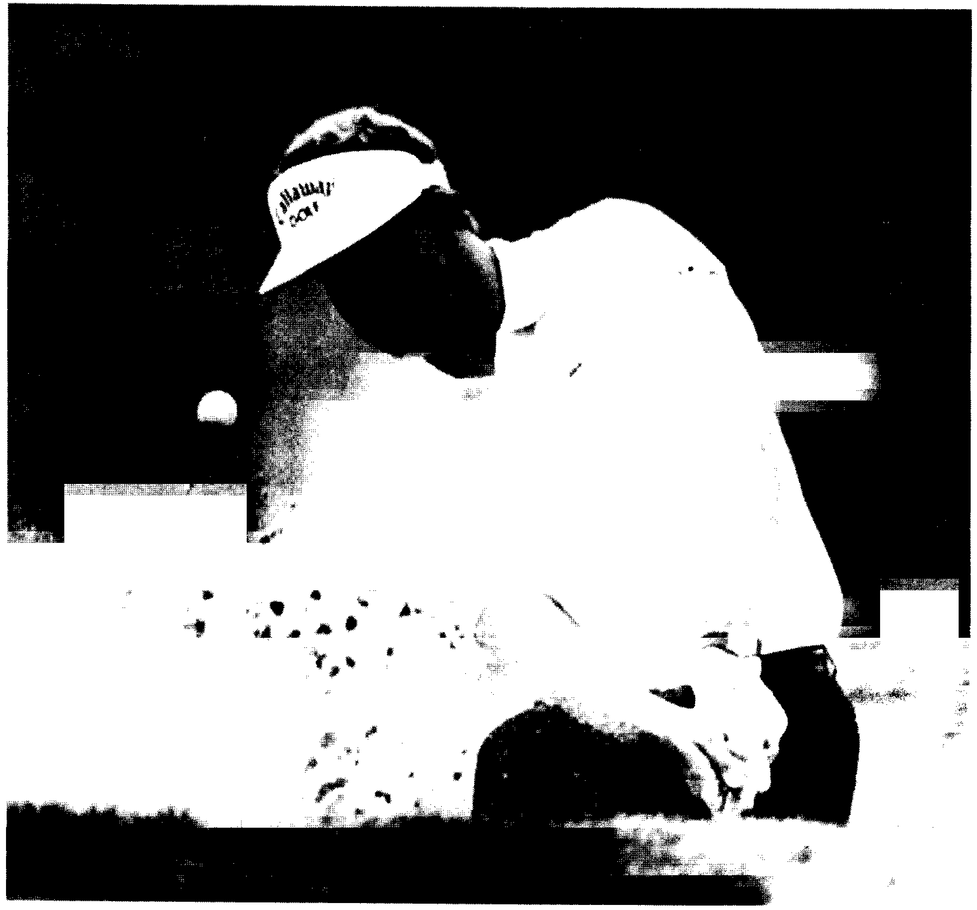

A golf course which has been sensitively designed and managed, in a way which works with nature rather than against it, is normally more interesting and challenging. This is one of the reasons why links courses are still respected as a real test of golf. Playing on more natural courses is an opportunity to get back to the original intention of the game - a test against the hazards that nature provided. It is always a priority of mine when I am working on the design of a golf course to work within these principles.

It is important that all clubs look at the qualities of their local environment to ensure that wildlife and habitats are conserved and to make sure that the quality of the golf course and its surrounds are not jeopardised for future golfing generations.

The Golf Bag offers a great deal of valuable information to golf clubs, golf course architects and designers.

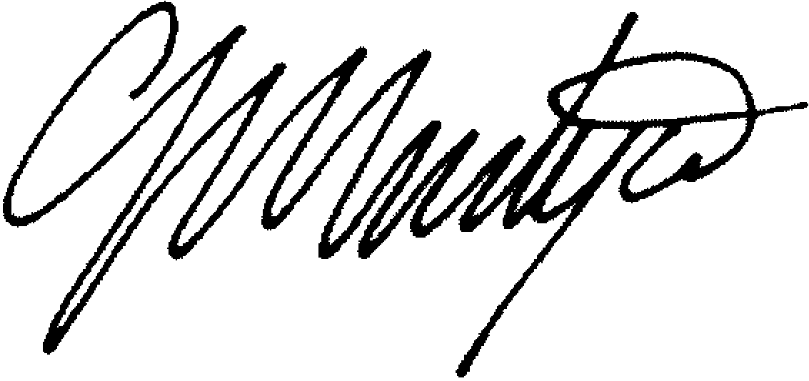

List of contents of the Golf Bag

List of Contents of the Golf Bag:

- A Course for All Seasons

- An Environmental Management Programme For Golf Courses

- Golf’s Natural Heritage

- The Committed to Green Handbook For Golf Courses

- Valderamma Environmental Statement

- A Guide to Habitat Creation

- A Management Guide to Birds of Scottish Farmland

- A Practical Guide to Ecological Management of the Golf Course

- Boxes, Baskets and Platforms: Artificial Nest Sites for Owls and other Birds of Prey

- Bracken Management Handbook 11. Dry stone Walling: A Practical Handbook

12. Hedging: A Practical Handbook

13. Managing Ponds for Wildlife 14. Sand Dunes: A Practical Handbook

15. Studies In Golf Course Management No 1:Heathland / Moorland Management

16. The Lowland Grassland Management Handbook 17. Trees and Aftercare: A Practical Handbook

18. Waterways and Wetlands: A Practical Handbook 19. Woodlands: A Practical Handbook

20. Coastal Erosion and Tourism in Scotland 21. Community Woodland Design Guidelines

22. Golf Courses and Associated Developments 23. Golf Courses in the Countryside

24. Nature Conservation and Golf Course Development: Best Practice Advice

25. Guidance on Public Recreational Access on Golf Courses

26. Gardens and Designed Landscapes

27. In The Rough? Golf Courses and Landscape Parks

28. An IPM Approach to Turf and Lawn Management

29. Developing An Effective Energy Policy 30. The Green Office Action Plan

31. Who’s who In The Environment: Scotland

32. Video: Committed to Green 33. Video: Golf Course Ecology 34. Video: Nature’s Way

35. Leaflet Folder. The leaflet folder contains numerous items covering a wide range of topics and represents an important part of the golf bag. Readers are recommended to refer to the description of the folder in this section which gives a full list of its contents.

36. Case Studies Folder. The case studies folder highlights work other golf clubs have done, and includes examples of Course Management Plans, Landscape Assessments, Wildlife and Habitat surveys, Environmental Leaflets, and technical summaries of miscellaneous environmental projects.

37. Log Book.

List of Bag Managers

SCOTTISH GOLF COURSE WILDLIFE GROUP

CONTACT LIST FOR GOLF BAG MANAGERS - as at 14 / 6 / 99

EDINBURGH AND LOTHIANS

- Mr Douglas Horn, Course Manager / Professional, Mortonhall Golf Club, 231 Braid Hills Road, Edinburgh, EH10 6PB, Tel. 0131 447 5185

- Mr Tom Murray, Course Manager, Ratho Park Golf Club, 3a Ratho Park Gardens, Ratho, Edinburgh, EH28 8NX, Tel. 0131 333 4126

- Mr Tom King, Manager, King’s Acre Golf Course, Lasswade, Midlothian, EH18 1AU Tel. 0131 663 3456, Fax. 0131 663 7076

- Ms Elspeth Coutts, Edinburgh Greenbelt Trust, Laundry House, Dalkeith Country Park, Midlothian, EH22 2NA, Tel. 0131 654 1933, Fax. 0131 654 2229

- Mr Jonathan Smith, Scottish Golf Course Wildlife Group, Stables, Dalkeith Country Park, Midlothian, EH22 2NA, Tel. 0131 660 9480

- Mr Norman Wood, Course Manager, Haddington Golf Club, Amisfield Park, Haddington, East Lothian, EH41 4QE, Tel. 01620 823885, Mobile 0370574039

- Mr David Roy, General Manager, Linlithgow Golf Club, Braehead, Linlithgow, West Lothian, EH49 6QF, Tel. 01506 842 505, Fax. 01506 844 764

- Ms Beverly Stevens, Lecturer, Oatridge College, Ecclesmachan, West Lothian, EH52 6NH, Tel. 01506 854387, Fax. 01506 853373, E-mail. OATRIDGE_ AGRICULTURAL_COLLEE_EDU@msn.com.

BORDERS

- Ms Roz Bowman, Scottish Natural Heritage, Anderson’s Chambers, Market Street, Galashiels, TD1 3AF, Tel. 01896 756652, Fax. 01896 750427

- Mr Bruce Cruickshank, Course Manager, Roxburghe Golf Course, Sunlaws, Kelso, Roxburghshire, TD5 8JZ, Tel. 01573 450394, Fax. 01573 450611

LANARKSHIRE, STIRLINGSHIRE AND CENTRAL BELT

- Mr Rob Garner, Central Scotland Countryside Trust, Hillhouseridge, Shottskirk Road, Shotts, ML7 4JS, Tel. 01501822015, Fax. 01501 823919, E-mail, WWW.CSCT.CO.UK

- Mr Charles Cumming, Central Scotland Countryside Trust, Hillhouseridge, Shottskirk Road, Shotts, ML7 4JS, Tel. 01501 822015, Fax. 01501 823919, E-mail, WWW.CSCT.CO.UK

- Mr Iain Hutton, Scottish Golf Union, 18 Turret Drive, Polmont, Falkirk, Tel. 01324 712585, Fax. 01324 684392, E-mail, IAIN C HUTTON- FALKIRK.DEMON.CO.UK

- Mr Graham Taylor, Director, Kames Country Club Ltd, Eastend, Cleghorn, Lanark, ML11 8NR, Tel. 01555 870015, Fax. 01555 870022

- Mr William Abernethy, Scottish Golf Union, 54 Whins Road, Alloa, Stirlingshire, Tel. 01259 722857

- Mr Joe Wallace, Course Manager, Glenbervie Golf Club, Stirling Road, Larbert, FK5 4SJ, Tel. 01324 562983, Mobile 0370 832032

- Mr Bruce Reekie, Environment Manager, The Gleneagles Hotel, Auchterarder, Perthshire, PH3 1NF, Tel. 01764 694287, Fax. 01764 694298

- Mr Graham Harbut, Leisure and Cultural Services, Perth and Kinross Council, 3-5 High Street, Perth, PH1 5JS, Tel. 01738 475211, Fax. 01738 475210

DUNDEE and ANGUS

- Mr Jack Clinton, Scottish Golf Union, 57 Camperdown Road, Dundee, DD3 8RN, Tel. 01382 884741

- Mr Bill Duncan, Head Greenkeeper, Panmure Golf Club, Burnside Road, Barry, Carnoustie, DD7 7RT, Tel. 01241 855120, Fax. 01241 859737, Mobile 0580 427080

- Mr Paul Murphy, Course Manager, Downfield Golf Club, Turnberry Avenue, Dundee, DD2 3QP, Tel. 01382 825595

- Mr Alan Holmes, Course Manager, Blairgowrie Golf Club, Rosebank, Blairgowrie, PH10 6LG, Tel. 01250 872622, Fax. 01250 875451

NORTH EAST

- Mr George Davidson, Arts and Recreation, Aberdeen City Council, 5th Floor, St. Nicholas House, Aberdeen, AB10 1XJ, Tel. 01224 522366

- Mr George Ironside, Secretary, McDonald Golf Club, Hospital Road, Ellon, Aberdeenshire, AB41 9AW, Tel. 01358 720576, Fax. 01358 720001, E-mail mcdonald.golf@virgin.net

- Mr Dale Robertson, Course Manager, Newmachar Golf Club, Swailend Road, Newmachar, Aberdeenshire, AB5 0NU, Tel. 01651 863002

- Mr Ronald Menzies, Scottish Golf Union, Vilamar, Portlethen Village, Aberdeen, AB12 4QP, Tel. 01224 780033

NORTH

- Mr Neil Ballingall, Courses Manager, Moray Golf Club, Stotfield Road, Lossiemouth, Morayshire, IV31 6QS, Tel. 01343 812018, Fax. 01343 815102

- Mr Bob MacKay, Course Manager, Royal Dornoch Golf Club, Golf Road, Dornoch, IV25 3LW, Tel. 01862 810219 / 810011

- Mr Alexander Robertson, Scottish Golf Union, Struan Rise, Church Road, Garmouth, IV32 7LS, Tel. 01343870231

- Mr Alan Dobbie, Course Manager, Boat of Garten Golf Course, Nethybridge Road, Boat of Garten, PH24 3BQ, Tel. 01479 831549, Mobile 0421646839

- Mr Alasdair McLaren, BIGGA Education Convener / Craggan Golf Course, Lower Craggan, Grantown-on-Spey, PH26 3NT, Tel.and Fax. 01479 872570, E-mail Alistair McLaren@Craggan,Freeserve.co.uk

- Mr Hugh MacIntyre, Scottish Golf Union, 34 Drumfada Terrace, Corpach, Fort William, PH33 7JU, Tel. 01397 772274

- Mr Fraser Mackenzie, Scottish Natural Heritage, 27 Ardconnel Terrace, Inverness, IV2 3AE, Tel.01463712221, Fax.01463 712675

FIFE

- Ms Sharon Milne, Scottish National Golf Centre, Drumoig, Leuchars, Fife, KY16 0DW, Tel. 01382 541144, Fax. 01382 541133

- Mr Owen Browne, Course Manager, The Dukes Course, Craigtoun, St Andrews, Fife, KY16 8NS, Tel. 01334 477595, Fax. 01334 475777, E-mail oldcoursehotel@standrews.co.uk

- Mr Thomas Spence, Greenkeeper Instructor, Elmwood College, Rursec Mains, Cuparmuir, Cupar, KY15 5QT, Tel. 01334 658914, Fax. 01334 658918

- Mr Ian Davidson, Scottish Golf Union, 7 McInnes Road, Markinch, Fife, KY7 6BA, Tel. 01592 752187

- Mr Derek Lee, Scottish Golf Union, 13 Greenmantle Place, Glenrothes, Fife, KY6 3QQ, Tel. 01592 745431

GLASGOW and surrounds

- Mr Colin Urquart, Senior Lecturer, Langside College, School of Horticulture, Rutherglen Campus, Buchanan Drive, Rutherglen, G73 3PF, Tel. 0141 647 6300, Fax. 0141 647 5895, E-mail CSURQUHART@chezmois/.demon.co.uk

- Mr Robert Hogarth, Course Manager, Cathcart Castle Golf Club, Mearns Road, Clarkston, Glasgow, G76 7YL, Tel. 0141 638 9449 ext30, Mobile 0402070145, Fax. 0141638 1201

- Mr John Scott, Course Manager, Kirkhill Golf Club, Greenlees Road, Cambuslang, Glasgow, G72 8YN, Tel. 0468 412105, Fax. 0141 881 8499

- Mr Chris Bothwell, Golf and Outdoor Sports Training Association, Clydeway Centre, Finneston, Glasgow, Tel. 0141 248 2772, Fax. 0141 248 2453

- Mr William Mitchell, Scottish Golf Union, 47 Troubridge Avenue, Kilbarchan, Renfrewshire, PA10 2AU, Tel. 01505 705 450

- Mr Ronnie Bunting, Course Manager, Kilmacolm Golf Club, Porterfield Road, Kilmacolm, Renfrewshire, Tel. 01505 872139, Fax. 01505874007

- Mr John Robertson, Course Manager, Hilton Park Golf Club, Stockiemuir Road, Milngavie, G62 7HB Tel. 0141 956 6844

- Mr James Cuthbertson, Scottish Golf Union, 60 Beeches Road, Duntocher, G81 6HW, Dumbartonshire, Tel. 01389 875256

ARGYLL

- Mr Dan Hunt, Scottish Natural Heritage, 1 Kilmory Industrial Estate, Kilmory, Lochgilphead, Argyll, PA31 8RR, Tel. 01546 603611, Fax. 01546 602298

SOUTH

- Mr David Woodbyrne, Head Greenkeeper, Southerness Golf Club, Southerness, Kirkbean, Dumfries, DG2 8AZ, Tel. 01387 880677, Fax. 01387 880644

- Mr Frank Woods, Scottish Golf Union, 9 Robison Drive, Dumfries, DG2 7RR, Tel. 01384 252911

- Mr Douglas Gillespie, Brighouse Bay Golf Course, Borgue, Kirkcudbright, Tel. 01557 870267, Fax. 01557 870319

- Mr Ian Langford, Scottish Natural Heritage, 23 Albert Street, Newton Stewart, Wigtonshire, DG8 6EF, Tel. 01671 403440, Fax. 01671 402399

SOUTH WEST

- Mr Jim Paton, Course Manager, West Kilbride Golf Club, Seamill, West Kilbride, KA23 9HT, Tel and Fax. 01294 823210

- Mr Ken Gibb, Local Agenda 21 Officer, South Ayrshire Council, Burns House, Burns Statue Square, Ayr, KA7 1UT, Tel. 01292 616288, Fax. 01292 616161, E-mail Ken.gibb@gw.south-ayrshire.gov.uk

- Mr Graeme Walker, Scottish Natural Heritage, 2 Berresford Terrace, Ayr, KA7 2EG, Tel. 01292 261392, Fax. 01292 269493

- Mr David McKie, Scottish Golf Union, 53 Kirkmuir Drive, Stewarton, Ayrshire, Tel. 01560 482237, E-mail DAVE@AGAGOLF.FREESERVE.CO.UK

